Phet Simulator: Name: _________________________

Static Electricity! Date: ____________ Period: ______

**Part A:** Go to the following: <http://phet.colorado.edu/en/simulation/balloons-and-static-electricity> and click **Play**!

1. Take a moment to look at the items the simulator window is displaying (balloon, sweater, wall, charges, etc.)
2. a) **Sketch** the charges on the sweater AND the balloon in the **BEFORE** box to the left.
3. Then, rub the balloon on the sweater and watch what happens! Draw the charges on both items in the **AFTER** box on the right.

**Sweater and balloon BEFORE Sweater and balloon AFTER**

Overall charge of sweater: ____0 Neutral____ Overall charge of sweater: ____positive____

Overall charge of balloon: ____0_Neutral____ Overall charge of balloon: ____negative______

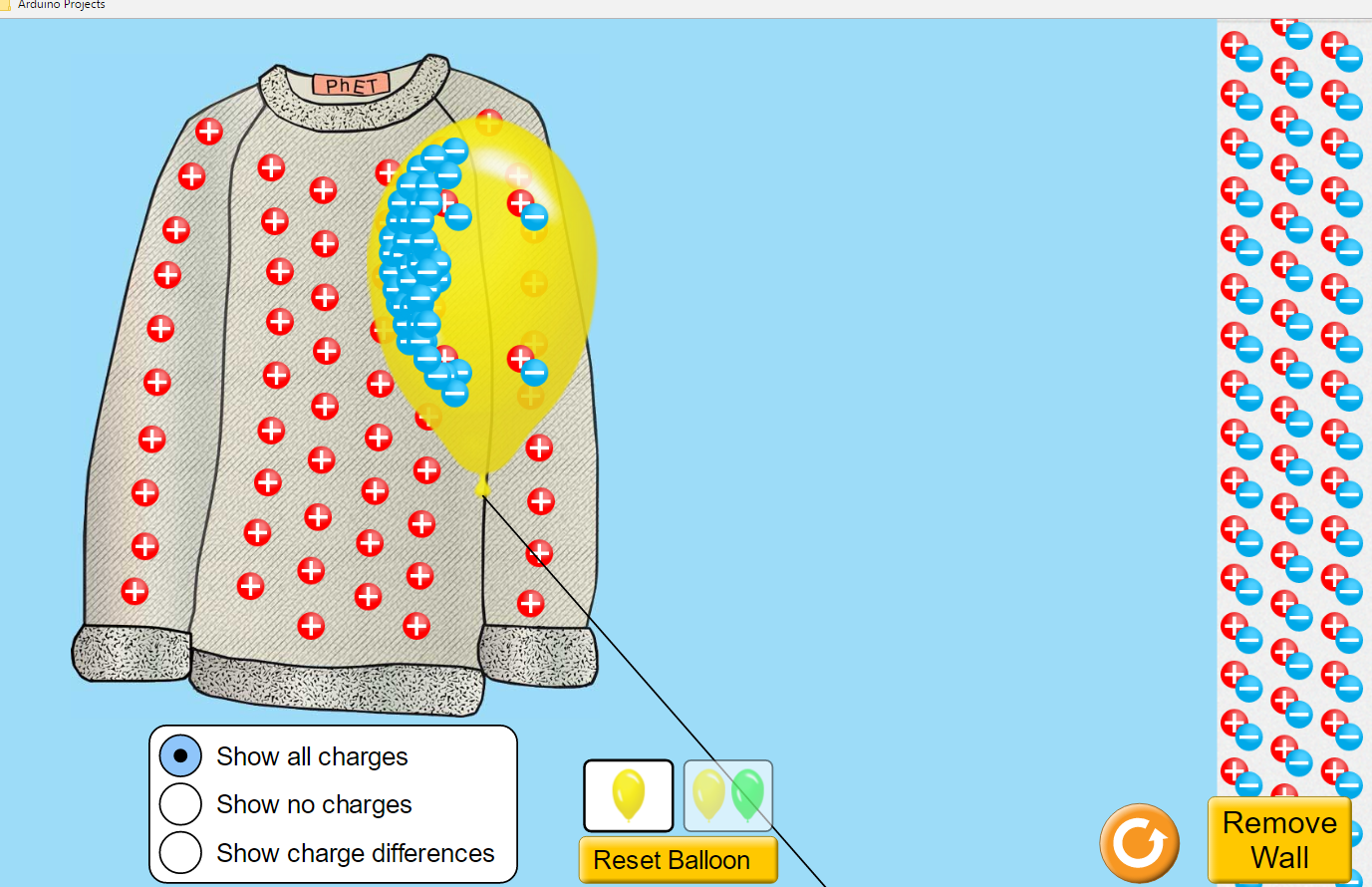

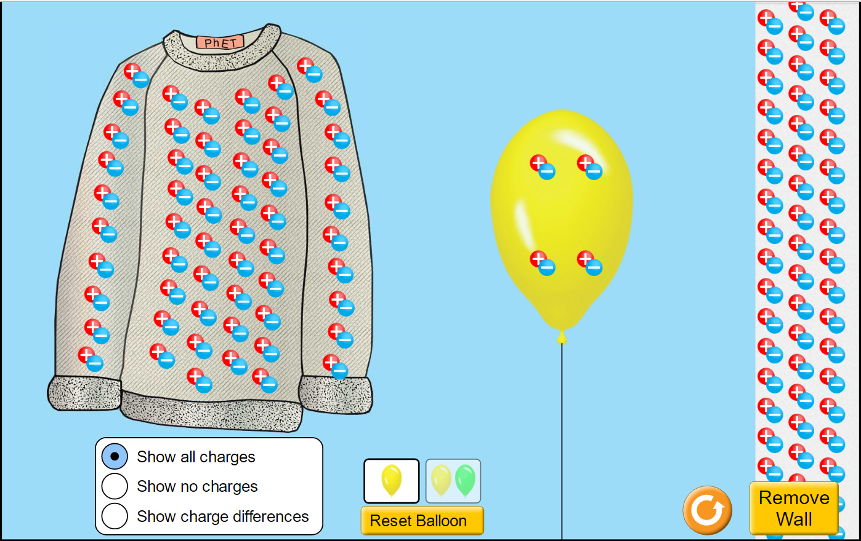

1. Remove the balloon from the sweater and attempt to place it **directly in between the sweater and the wall**. Do this several times and observe what happens. **Explain** why the balloon is attracted to one item more than the other.

The balloon attracts to the sweater because it has a more powerful charge. The sweater has a high amount of protons over electrons while the wall has a neutral charge. Also the balloon will not get attracted to the wall unless it is polarized and the balloon needs to be in a close proximity to the wall for it to create a strong polarization effect and to attract to it.

1. Bring the balloon all the way to the wall so that they are touching and release it. Is the balloon is able to stick to the wall? Do you think it is as ***strong*** an attraction as to the sweater? **Explain** why or why not.

The wall would have an equal attraction as the sweater. This is because when it polarizes the wall all electrons move out of its path so the area around the wall will be positive the same amount as the wall. Even though the wall has an overall neutral charge the area the balloon is attracted to is a positive charge. So the balloon will have as strong of an attraction while the wall is polarized but not when it is not polarized.

1. Click “**Reset Balloon**” and then click on the image of TWO balloons just above the “**Reset Balloon**” button. Figure out the following missions and **draw diagrams demonstrating how you are able to accomplish each mission**!

a) Make the two balloons **repel**! b) Make the two balloons **attract**!

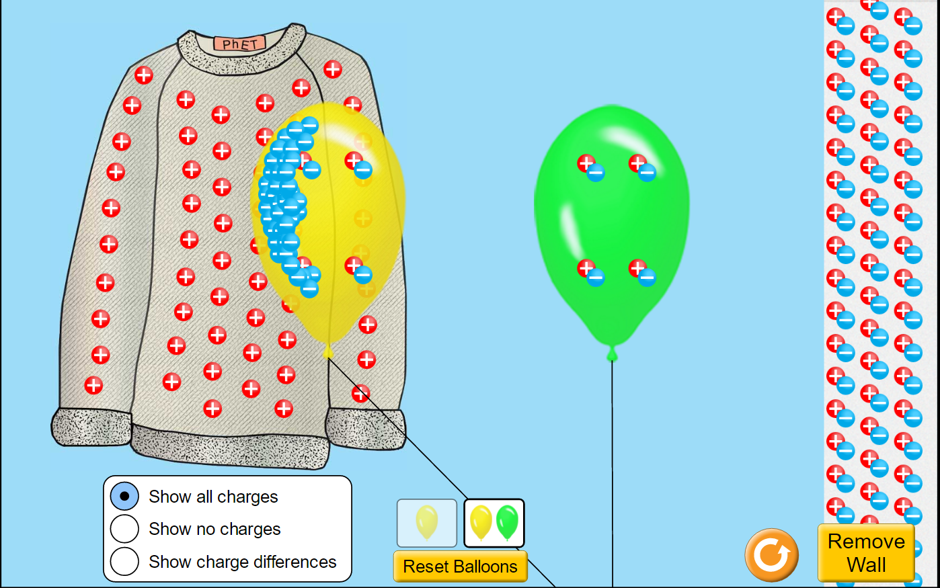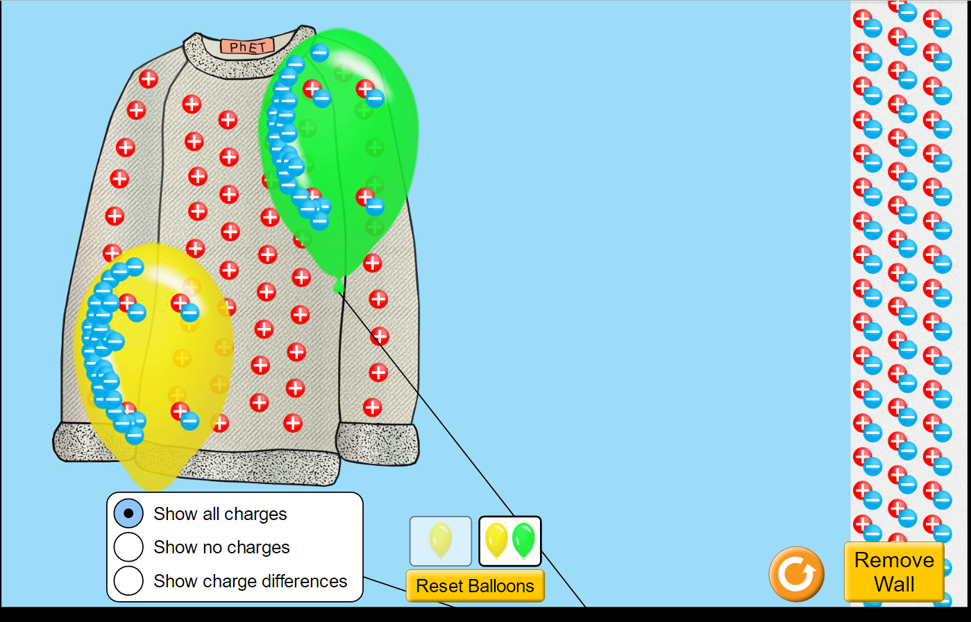

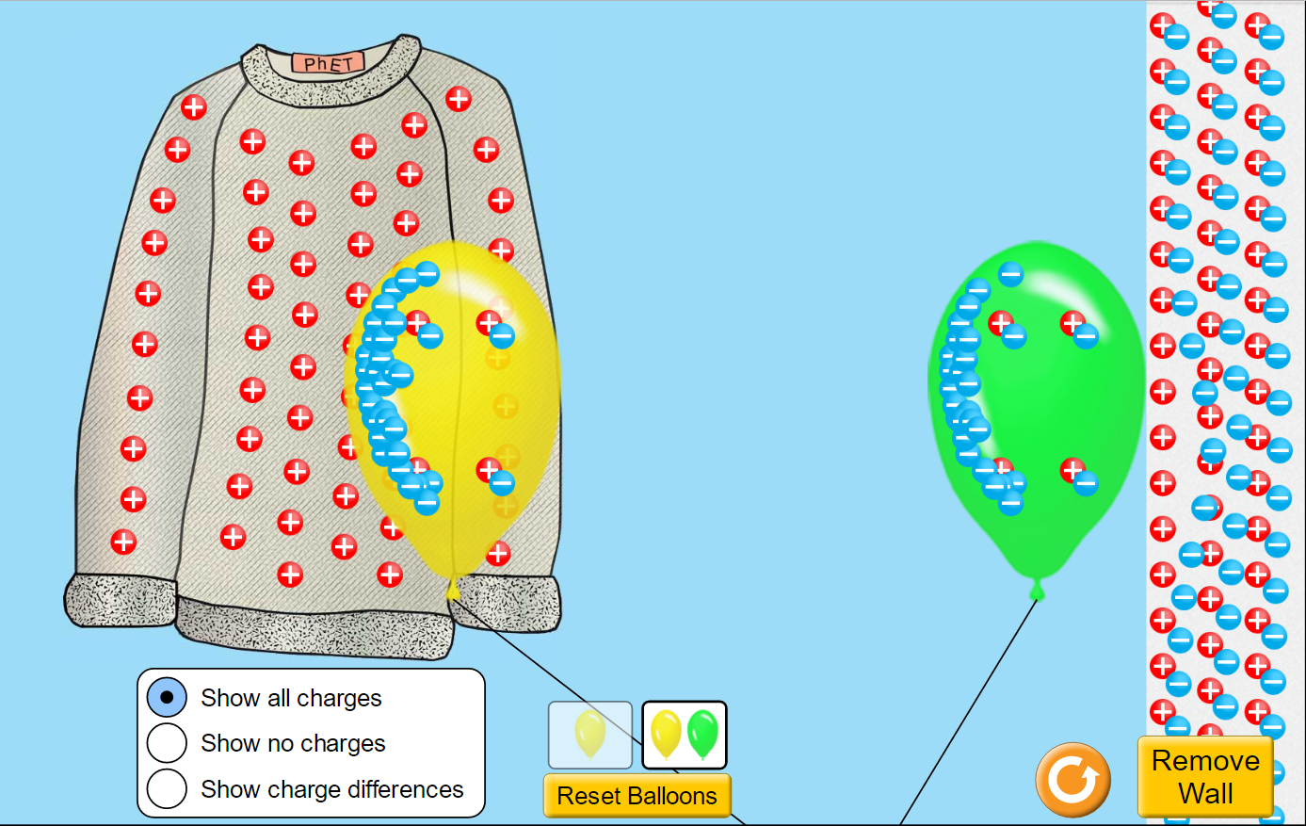

Charges of Balloons: yellow is negative, green is negative Charges of Balloons: the yellow balloon is negative while the green is neutral and he negative balloon should polarize the neutral one however the simulation does not work that way.

**Part B: John Travoltage!**

Go to the following: <http://phet.colorado.edu/en/simulation/john-travoltage> and click **Play**!

1. Drag John Travoltage’s FOOT across the carpet. Describe what happens!

The electrons build up in his leg through his foot rubbing against the carpet which uses friction to move the electrons in the carpet into his leg. So the buildup in his leg transfers throughout his body until it is grounded.

1. a) Why does **carpet** tend to produce differences in static electricity more than hardwood or tile floors (think!)?

b) Why do you sometimes feel a shock when you touch **metallic** objects (like the doorknob)?

The carpet is higher on the electrostatic series than other objects so that means it has a higher tendency to lose electrons through these methods. So the carpet loses electrons better than wood or tiles therefore it is higher on the electrostatic series. When you touch a metallic object it acts like connecting a circuit the electrons get grounded into the metal it is like a switch when you have electrons in your system and you touch a metal object the electrons flow through you like a circuit would with a button.

1. Why doesn’t John Travoltage get a shock if he touches the doorknob ***without*** rubbing his foot on the carpet?

John Travoltage does not get zapped because he does not have a buildup of excess electrons. He is neutral at the start so when he touches metal he has no electrons to move while when he rubs his foot on the ground he gains those excess electrons.

1. Observe which **direction** the spark travels when John Travoltage’s finger comes close to the metal doorknob.
2. Draw a diagram of his finger and the doorknob below.
3. Label the **CHARGES** (positive, negative, neutral) of both objects and show the direction the spark is traveling!

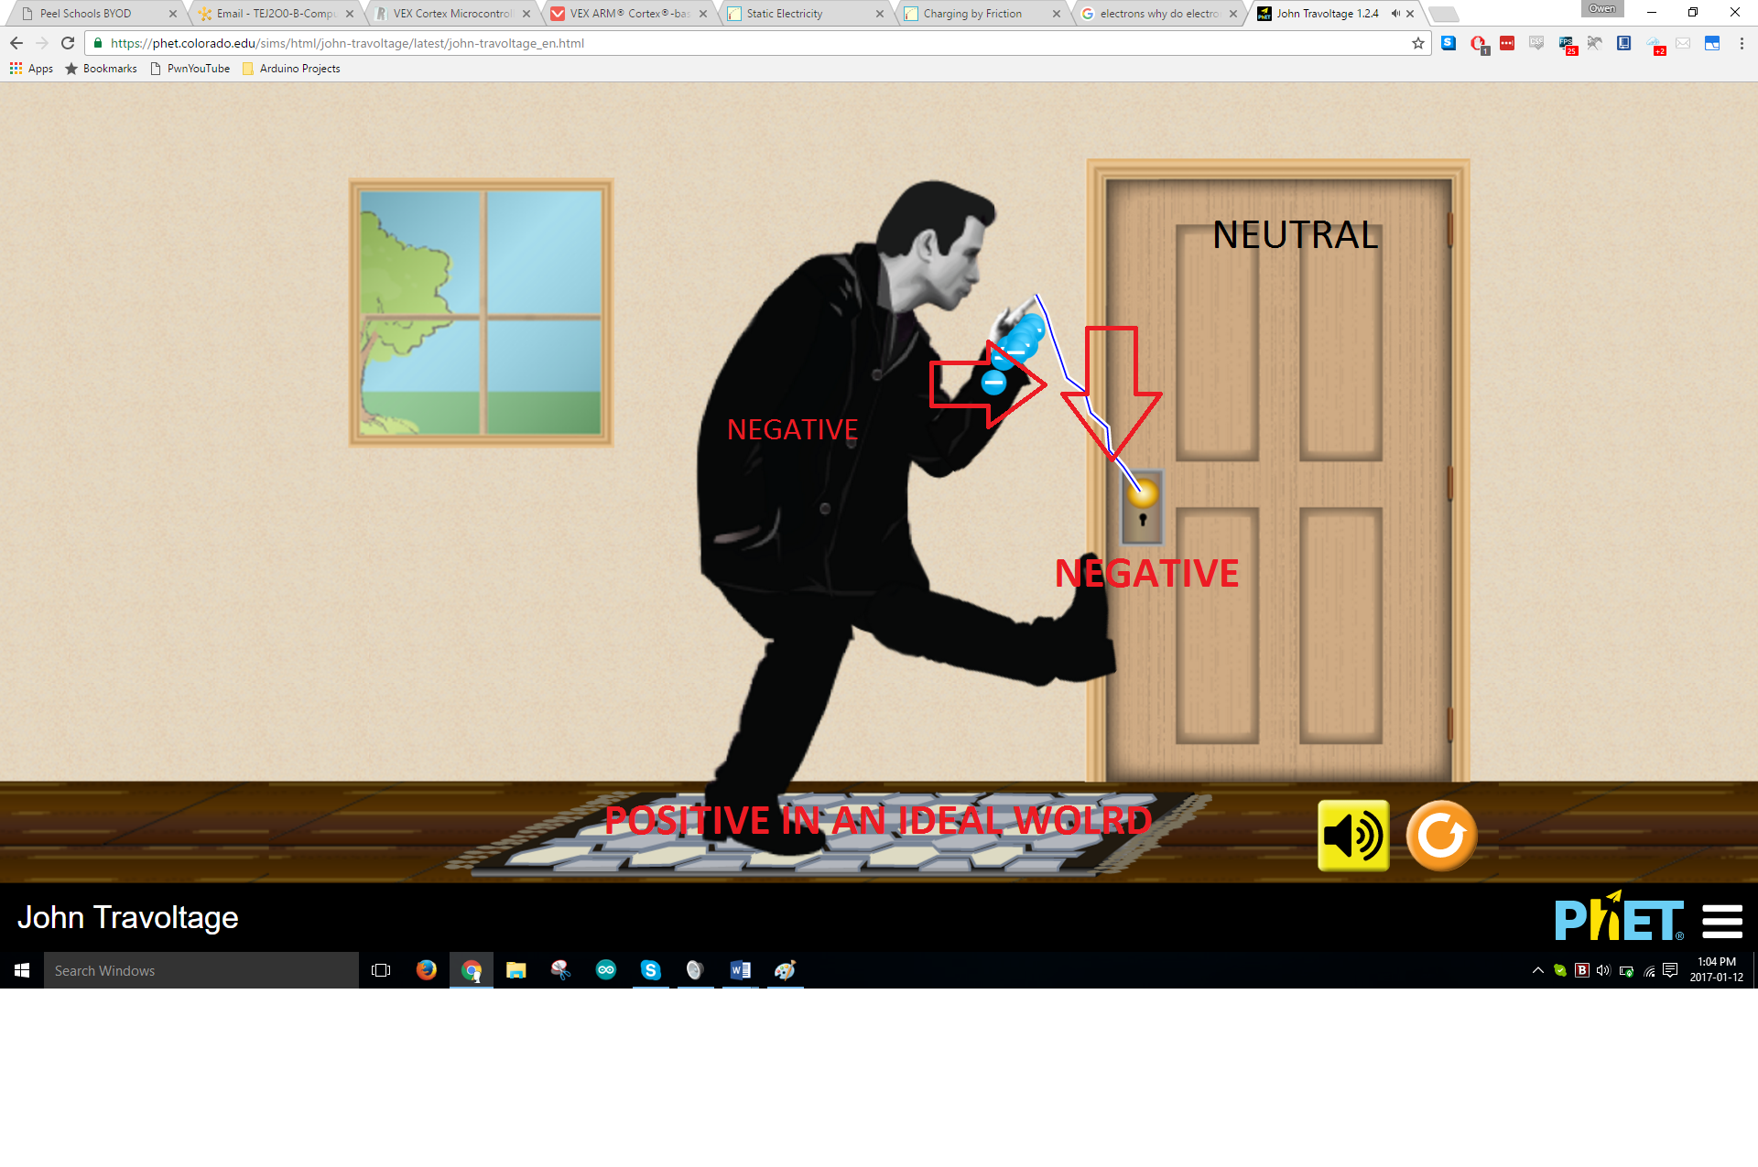

1. Think about one time you clearly remember experiencing a static electric shock. What must have caused the build up of charges to occur? Which way did the spark travel in your example when you felt a shock? **Draw a diagram below that clearly shows the build up of charge in all objects involved** and **shows the way the spark traveled**:

I was petting my dog and then when I stood up to leave I touched the doorknob and I got shocked. Since the dog’s fur had an excess of electrons it had a negative charge. When I pet the dog the electrons passed to my hand through the process of friction. This would then give my hand a negative charge and an excess of electrons. Then when I stood up and touched the doorknob I would experience a static shock. This shock happened because the excess of electrons in my system wanted to leave my body so it transferred into the doorknob. So due to polarization the negative charges repel the negative charges in the doorknob so the area near my hand on the doorknob was positive so the electrons wanted to move there. So the spark travelled from my hand to the doorknob.

